
MAHARASHTRA STATE BOARD OF TECHNICAL EDUCATION , Mumbai

PROJECT REPORT ON
Interactive Personality & Career Recommendation Quiz Using Python.
SUBMITTED BY:
- Nirbhay More
- Gaus Mulla
- Gitesh Netkar
- Akash Jaiswar

GUIDED BY:
Prof. Neha S.

DEPARTMENT OF ARTIFICAL INTELLIGENCE & MACHINE LEARNING

Fr. Agnel Polytechnic, Vashi,
ACADEMIC YEAR-2026-2027


FR. AGNEL POLYTECHNIC VASHI, NAVI MUMBAI - 400703

PROJECT NAME: -
Interactive Personality & Career Recommendation Quiz Using Python.

NAME ROLL NO
- Nirbhay More 25935
- Gaus Mulla 25936
- Gitesh Netkar 25938
- Akash Jaiswar 25925

Prof. Neha S Prof. Neha S.
(SUBJECT TEACHER) (PROJECT GUIDE)

Contents
ACKNOWLEDGEMENT 4
1. Introduction 5
2. Problem Statement 6
3. Objectives 7
4. Technologies Used 8
5. Hardware Requirements 9
6. Software Requirements 10
7. Working of the System 11
8. SYSTEM FLOW 12
9. CODE 13
10. Important Functions Used 17
11. Output 19
12. Advantages 23
12. Limitations 24
13. Future Scope 25
13. Conclusion 26

ACKNOWLEDGEMENT

We would like to express our sincere thanks to our project guide and subject teacher for their valuable guidance and support during the development of our project, “Interactive Personality & Career Recommendation Quiz Using Python.”
We are thankful to the Department of Artificial Intelligence & Machine Learning, Fr. Agnel Polytechnic, Vashi, for providing us with the opportunity to work on this project.
We would also like to thank our teachers and classmates for their suggestions and support during the development and testing of the project.
Finally, we are grateful to our parents and friends for their continuous encouragement and support throughout the completion of this microproject.

Interactive Personality & Career Recommendation Quiz Using Python

1. Introduction

The Interactive Personality & Career Recommendation Quiz Using Python is a Python-based application developed to provide users with a simple and interactive way to understand their personality type and explore suitable career options.
The project presents a series of questions related to the user's interests, preferences, behaviour and way of thinking. The user selects an option for each question, and the program calculates the score for different personality categories based on the selected answers.
After completing the quiz, the system displays the personality type with the highest score and provides career suggestions related to that personality type. The application also provides an option to restart the quiz and take it again.
The project is developed using Python and Tkinter. The quiz questions are stored separately, while the scoring and result logic are handled using Python functions. This project demonstrates the practical use of Python concepts such as functions, lists, conditional statements, loops, modules and GUI programming.

2. Problem Statement

Students often have different interests, skills and ways of thinking, but they may not always have a simple way to explore which type of career may suit their interests.
Traditional career guidance can require personal counselling and may not always be easily available for a quick initial understanding.
Therefore, there is a need for a simple and interactive application that can ask users a set of personality-related questions and provide a basic personality result along with related career suggestions.
The proposed project solves this problem by developing a Python-based quiz application that evaluates the user's answers using predefined scoring rules and displays the corresponding personality type and career recommendations.

3. Objectives

The main objectives of the project are:
- To develop an interactive personality quiz using Python.
- To provide a simple graphical user interface for answering quiz questions.
- To calculate personality scores based on the user's selected answers.
- To identify the personality category with the highest score.
- To provide career suggestions based on the obtained personality category.
- To allow the user to restart and take the quiz again.
- To understand and apply Python concepts such as functions, conditional statements, lists and modules.
- To gain practical knowledge of GUI development using Tkinter.

4. Technologies Used

Technology | Purpose
Python | Main programming language used to develop the project
Tkinter | Used to create the graphical user interface of the quiz
Python Functions | Used to divide the program into different tasks and make the code easier to manage
Lists and Dictionaries | Used to store quiz questions, options and related information
Conditional Statements | Used for score calculation and deciding the final personality result
Python Modules | Used to separate the questions and quiz logic from the main program

5. Hardware Requirements

The following hardware is required to run the project:
- Computer/Laptop: Any basic computer or laptop
- Processor: Intel Core i3 or equivalent processor
- RAM: Minimum 4 GB
- Storage: Minimum 500 MB of free storage
- Display: Standard monitor or laptop display
- Keyboard and Mouse: Required for interacting with the application

6. Software Requirements

The following software is required to develop and run the project:
- Operating System: Windows / Linux / macOS
- Python: Python 3.x
- Code Editor: Visual Studio Code or any Python-supported IDE
- Tkinter: Python library used for creating the graphical user interface
- Python Modules: questions.py and quiz_logic.py
- Python File: main.py contains the main application code
- Terminal/Command Prompt: Used to run the Python program

Required Python Module :
import tkinter as tk

The project does not require an internet connection while running because the quiz questions, scoring logic and career recommendations are handled within the Python project files.

7. Working of the System

The system works as an interactive quiz application. The user answers a series of personality-related questions, and the program calculates the scores based on the selected answers.
The working of the system is as follows:
- The user starts the Python application.
- The main window of the quiz is displayed using Tkinter.
- The system displays the first personality-related question with multiple options.
- The user selects one option from the available choices.
- The selected answer is used for calculating the score of the related personality category.
- The user clicks the Next button to move to the next question.
- The same process continues until all the questions are answered.
- After the last question, the program calculates the total score of the different personality categories.
- The category having the highest score is selected as the user's personality type.
- The system displays the personality result on the result screen.
- Career suggestions related to the obtained personality type are also displayed.
- The user can click the Restart Quiz option to take the quiz again.

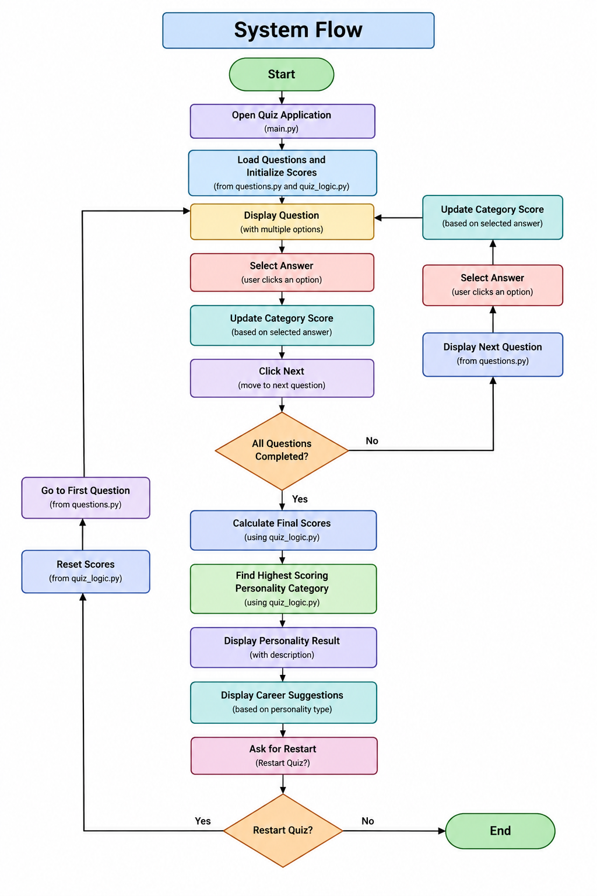
8. SYSTEM FLOW

9. CODE
main.py
import tkinter as tk
from tkinter import ttk

from questions import questions
from quiz_logic import calculate_score, get_result, scores

# MAIN WINDOW
window = tk.Tk()
window.title("Interactive Personality & Career Quiz")

# Bigger window so everything fits properly
window.geometry("900x650")
window.resizable(False, False)
window.configure(bg="#EEF3FF")

# COLORS
PURPLE = "#402080"
LIGHT_PURPLE = "#5B2CB6"
BLUE = "#2563EB"
GREEN = "#22A85A"
WHITE = "#FFFFFF"
BACKGROUND = "#EEF3FF"
TEXT = "#202124"
BORDER = "#D8DCE8"

# VARIABLES
current_question = 0
selected_answer = tk.IntVar(value=-1)

# HEADER
header = tk.Frame(
window,
bg=PURPLE,
height=115
)
header.pack(fill="x")
header.pack_propagate(False)

# Brain icon
brain_label = tk.Label(
header,
text="🧠",
font=("Segoe UI Emoji", 38),
bg=PURPLE,
fg=WHITE
)
brain_label.pack(
side="left",
padx=(35, 15)
)

# Header text
header_text = tk.Frame(
header,
bg=PURPLE
)
header_text.pack(
side="left",
pady=18
)

title_label = tk.Label(
header_text,
text="Interactive Personality & Career Quiz",
font=("Arial", 23, "bold"),
bg=PURPLE,
fg=WHITE
)
title_label.pack(anchor="w")

subtitle_label = tk.Label(
header_text,
text="Answer honestly to discover the best career paths for you!",
font=("Arial", 11),
bg=PURPLE,
fg=WHITE
)
subtitle_label.pack(
anchor="w",
pady=(5, 0)
)

# MAIN FRAME
main_frame = tk.Frame(
window,
bg=BACKGROUND
)
main_frame.pack(
fill="both",
expand=True
)

# PROGRESS FRAME
progress_frame = tk.Frame(
main_frame,
bg=WHITE,
highlightbackground=BORDER,
highlightthickness=1
)
progress_frame.pack(
fill="x",
padx=30,
pady=(18, 12)
)

question_number_label = tk.Label(
progress_frame,
text="",
font=("Arial", 12, "bold"),
bg=WHITE,
fg=TEXT
)

10. Important Functions Used

The following functions are mainly used in the project:
Function | Purpose
show_question() | Displays the current question and its options on the screen.
next_question() | Processes the selected answer, calculates the score and moves to the next question.
calculate_score() | Increases the score of the selected personality category.
get_result() | Finds the category with the highest score and returns the final personality type.
show_result() | Displays the final personality result and career suggestions to the user.
restart_quiz() | Resets the scores and starts the quiz again from the first question.
window.mainloop() | Keeps the Tkinter application running and allows the user to interact with the GUI.

1. show_question()
This function gets the current question from questions.py and displays the question and four options. It also updates the question number and progress percentage.
2. next_question()
This function checks the selected answer and identifies its personality category. It then calls calculate_score() and moves the quiz to the next question.
3. calculate_score(category)
This function is present in quiz_logic.py. It increases the score of the selected personality category by one.
4. get_result()
This function checks all four personality scores and returns the category having the highest score.
5. show_result()
This function displays the final personality type along with its description and related career suggestions.
6. restart_quiz()
This function resets all personality scores, sets the question number back to the first question and displays the quiz again.
7. window.mainloop()
This Tkinter function keeps the graphical application running and waits for user actions such as selecting an option or clicking a button.

11. Output

The project provides a graphical interface through which the user can take the personality quiz. The following screens are displayed during the execution of the project.

1. Quiz Start Screen
The application starts with the main quiz interface. It provides the title of the quiz and allows the user to begin answering the questions.
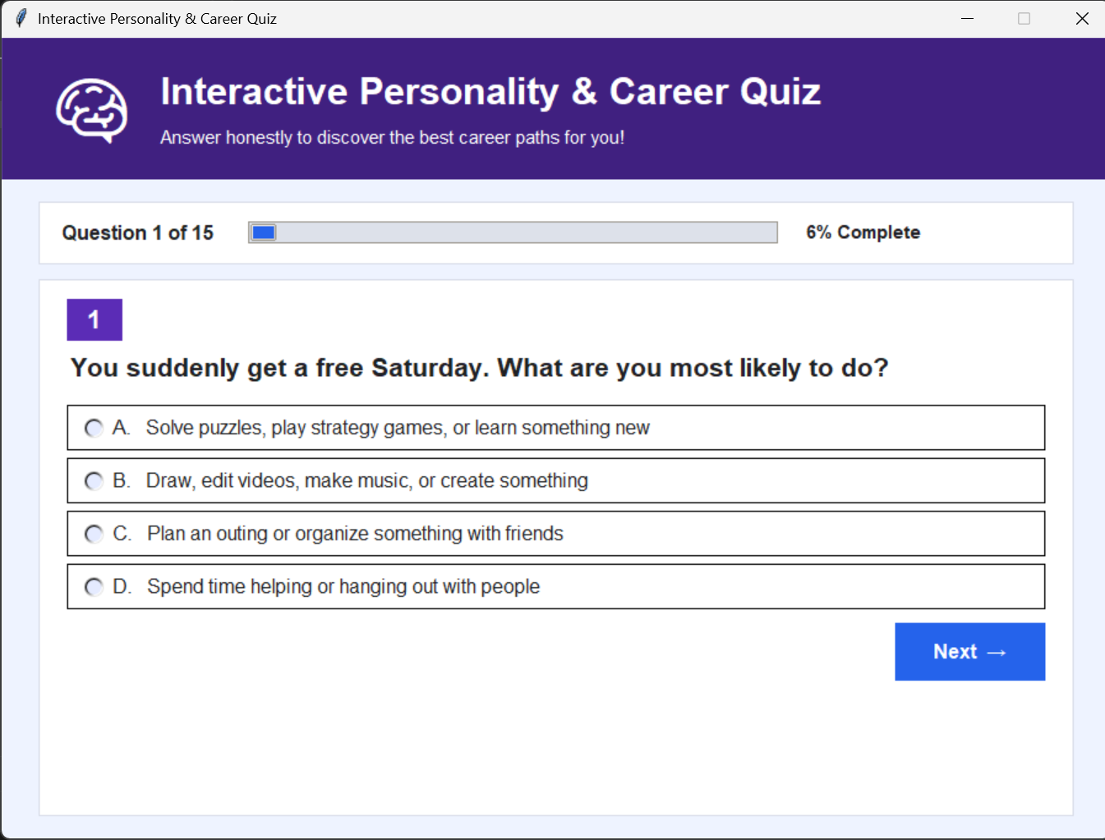

2. Question Screen
The question screen displays one personality-related question at a time along with four options. The user can select one option and move to the next question.
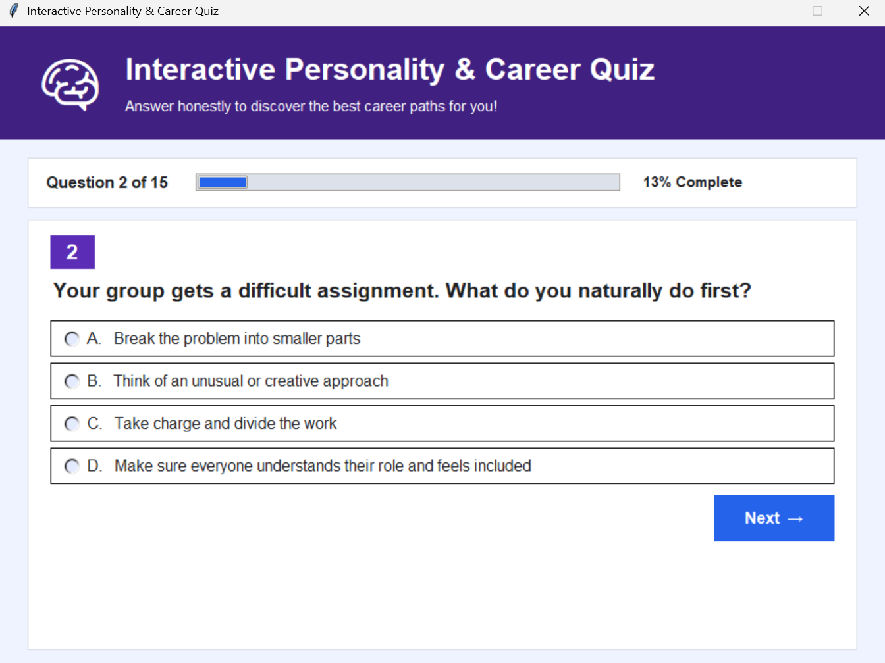

3. Quiz Progress
The application displays the current question number and progress while the user moves through the quiz. This helps the user understand how many questions have been completed.
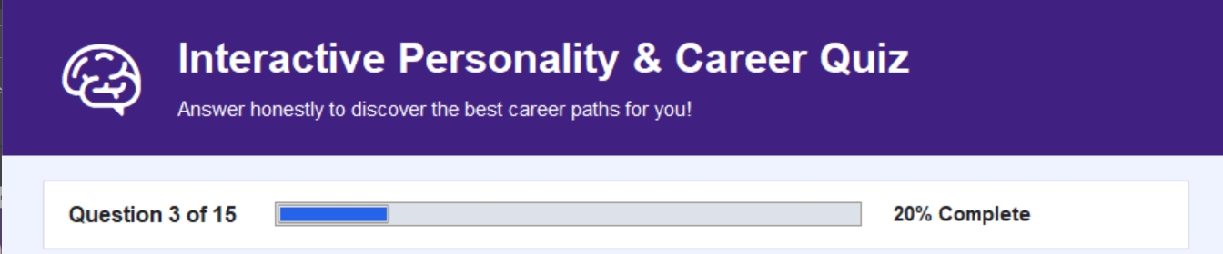

4. Personality Result Screen
After all questions are answered, the system calculates the scores of the personality categories and displays the category with the highest score.
The four personality categories used in the project are:
- Analytical Thinker
- Creative Innovator
- Leader
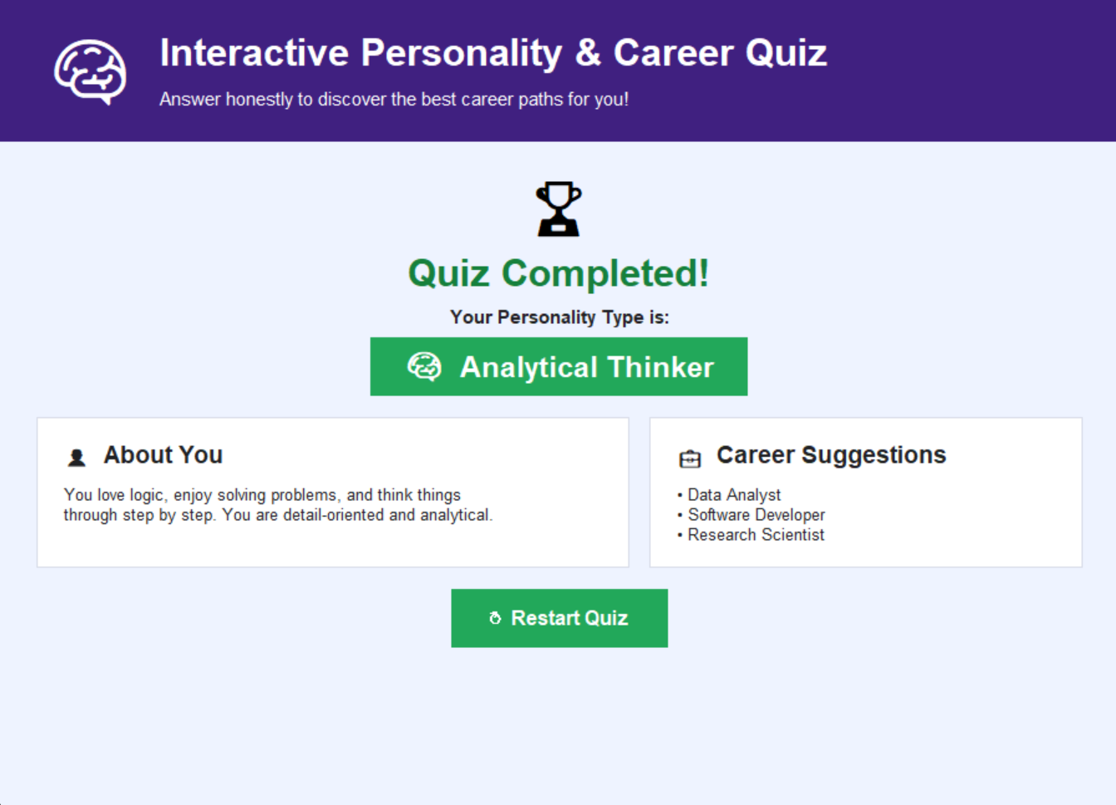
- Social Helper

5. Career Recommendation
Along with the personality result, the application displays career suggestions related to the obtained personality category.


6. Restart Quiz
The result screen provides an option to restart the quiz. When the quiz is restarted, the scores are reset and the user can answer the questions again from the beginning.


12. Advantages

The main advantages of the project are:
- Simple and easy-to-use graphical interface.
- Provides an interactive way to answer personality-related questions.
- Automatically calculates personality category scores.
- Displays the final personality category based on the user's answers.
- Provides career suggestions related to the obtained personality type.
- Allows the user to restart the quiz and take it again.
- Does not require an internet connection while running.
- Helps students understand the practical use of Python and Tkinter.
- Demonstrates the use of functions, modules, conditional statements and data structures in Python.

12. Limitations

The current version of the project has the following limitations:
- The quiz is based on a fixed set of predefined questions.
- The personality result is based on the scoring rules defined in the program.
- The career recommendations are predefined for each personality category.
- The system does not save the user's previous quiz results.
- The application does not provide detailed career guidance or counselling.
- The accuracy of the result depends on the user's selected answers.
- The project currently works as a desktop application and does not have a web or mobile version.
- The number of personality categories and career suggestions is limited in the current version.

13. Future Scope

The project can be improved in the future by adding the following features:
- More Questions: More questions can be added to make the quiz more detailed.
- Database Integration: User details and quiz results can be stored using MySQL or SQLite.
- Result History: Previous quiz results can be saved and viewed by the user.
- Improved Career Recommendations: More career options can be added for each personality category.
- User Login: A login system can be added to maintain individual user records.
- Detailed Reports: The system can generate a detailed report of the user's scores.
- Web Application: The project can be converted into a web-based application.
- AI/ML Integration: Machine learning techniques can be explored in a future version to analyse user responses in a more advanced way.
- Better Personalization: Recommendations can be improved by considering additional information such as interests, skills and educational preferences.
- Result Export: The final result can be exported as a PDF or other document format.

13. Conclusion

The Interactive Personality & Career Recommendation Quiz Using Python successfully demonstrates the development of a simple interactive quiz application using Python and Tkinter.
The system allows the user to answer a series of personality-related questions and calculates scores for different personality categories. After completing the quiz, it displays the category with the highest score along with related career suggestions.
The project helped us understand the practical implementation of Python concepts such as functions, conditional statements, lists, dictionaries, modules and GUI programming using Tkinter.
Although the current version uses predefined questions and scoring rules, it provides a good base for further development. Features such as database storage, result history, improved career recommendations and AI/ML-based analysis can be added in future versions.
Overall, this project provided practical experience in developing a Python application from planning and coding to testing and displaying the final result.

